Name _____________________________________ Date______________________

Writing

There are various types of writing in AP Social Studies. You will encounter all of these types of writing throughout your year. There are also different types of questions or essays you will need to write. Rarely will these be phrased as questions; it will be up to you to identify the question and from there, create an argument. Please also keep in mind that writing for AP Social Studies can be vastly different than the writings you will need to do for AP English.

Types of Writing (general)
Narrative | Students will be tasked with making a point or present information but in a more creative way in an essay of no less than five paragraphs. Ex: book report.
Expository | Students will be required to investigate an idea and create and argument that is supported more through definition, examples, and/or comparison than research (as in the argumentative) in an essay of no less than 5 paragraphs. Ex: FRQs.
Analytical | Students will be tasked with writing about another person’s writing to examine how and why they have written what they have written, and how it works together to accomplish the piece’s purpose. Ex: Speech analysis
Argumentative | Students will be required to investigate a topic, collect, generate, and evaluate evidence, and establish a position on the topic in an essay of no less than 5 paragraphs. Ex: DBQs.
Summary | Students will recap what they have read/seen in a concise writing that is no more than 1-2 paragraphs.
Informal | This will include writing that allows the student to connect more with their viewpoint: journals, collaborative writing, annotations, notes, blog posts.

Specific Types of Questions/Essays for AP Social Studies
Document Based Question (DBQ) | Students are given several documents and must apply them to the given question. They will be required to use the documents provided, and create and argument and support it with an essay in a given time frame.
Free Response Question (FRQ) | Students are given a question and several tasks to accomplish to answer that question. The initial question will require students to create a thesis and support it using the tasks.
Short Answer Question (SAQ) | Students will respond to a question with a 1-2 paragraphs.
Long Essay Question (LEQ) | Students will respond to a question with 3-5 paragraphs.
Change and Continuity Over Time (CCOT) | Students will be given a question and must recognize both changes regarding that topic as well as things that stayed true for that topic. They will required to have a thesis, as well as explain why both changes and continuities exist and/or occurred.

Activity 1: Look at the prompts given. Identify a) the type of question, b) the type of writing you will use, c) write out the actual question, and d) create a thesis statement for that prompt.

1. Over the last 25 years, presidential election campaigns became very candidate centered and less focused on issues and party labels. This change has been attributed both to how the media cover presidential campaigns and to how candidates use the media. Identify and explain two ways in which the media have contributed to candidate-centered presidential campaigns. Identify and explain two ways in which presidential candidates’ use of the media has contributed to candidate-centered campaigns.
a)
b)
c)

d)

2. Congress has the power to exercise legislative oversight over the federal bureaucracy to ensure acts of Congress and the President are being implemented properly. Many argue that Congress’ use of this power is ineffective.
a)
b)
c)

d)

3. Evaluate the extent to which trans-Atlantic interaction fostered change in labor systems in the British North American colonies from 1600 to 1763.
a)
b)
c)

d)

4. The goals of the Spanish and English in establishing colonies include some overlap, but had different impacts on the development of the New World.
a)
b)
c)

d)

Outlines are used to help you plan your writing. They can be detailed or not so much. Regardless of detail, an outline is set up by paragraphs and main ideas. Outlines use Roman Numerals and indented letters, and can usually demonstrate the “flow” of the paper and major points of an argument without extended writing. You will ALWAYS be required to write your complete thesis in your outline, however, this will most likely be the only complete sentence(s) that appears in your outline. **A WEB IS NOT AN OUTLINE**

Example:
Prompt: Many writers of the Constitution believed the federal judiciary would be the weakest of the three branches of government after granting the legislature and executive with substantial power. Today, however, many consider the Supreme Court to be the most powerful of the three branches, and perhaps dangerously undemocratic in its use of judicial review.
a) Compare and contrast the power of the Supreme Court with the power of Congress.
b) Define “judicial review,” a case in which it has been used, and how it impacted the Congress and/or the United States.
c) Describe two reasons the Supreme Court would be considered “undemocratic” when compared to Congress.

Type of Question:
Type of Writing:
Actual Question:

Outline
I. Introduction
a) The Constitution and branches of government
b) Previous problems with legislature
c) Why create a federal judiciary?
d) THESIS: While the Supreme Court is not the most powerful in comparison to Congress, it is has very specific powers that Congress does not, which allows the Supreme Court to appear powerful. Actions of the Court are often seen as undemocratic in nature, but overall the Court has a profound impact on the direction of domestic affairs and American culture.

II. Support #1: Comparing Congress and the Supreme Court
a) Powers of Congress
b) Power of Court
c) Examples of powers in use

III. Support #2: Undemocratic nature
a) Selection of Justices
b) Rule of Four and selection of cases
c) Constitutional Interpretation and Judicial Review
i) Case to be used: Brown v. Board

IV. Support #3: Impact of Court
a) How case used changed the US
b) How case used impacted Congress
c) Other “long-run” examples

V. Conclusion
a) How the Court compares to the Executive and Legislature
b) Why the Court is needed
c) How Court impacts country with fewer powers

A detailed outline would make a, b, and c into complete sentences to lend more detail to the structure of the paragraph. It would also ask for further examples, as seen in paragraph III above with “i)”. These would not be full sentences, but they would be specific.

Activity 2: Look at the thesis and outline above and evaluate the argument. Does it answer all parts of the question? Is there anything you would change? If so, what and why? If not, why not? Is this an effective argument? How so?

Activity 3: Choose the appropriate prompt for you class below and create an outline for that prompt. Use the outline from the example as a guide if you need to. Circle your prompt.

APUSH: Over the course of the 17th Century, the settlers in the Virginia colony faced a number of hardships. Examine the challenges that the Virginians faced and the ways their efforts changed the colony socially and economically.

AP GOV: Democracy is a key feature in the United States political system. Democracy is instilled and maintained through a set of values referred to as political culture. Many scholars believe that in spite of this shared culture, the United States is experiencing a culture war.

Type of Question:
Type of Writing:
Actual Question:

Outline
I. Introduction
a)

b)

c)

II.
a)

b)

c)

III.
a)

b)

c)

IV.
a)

b)

c)

V.
a)

b)

c)

AP Government FRQ rubrics are specific to the question. Looking at the prompt in the example, points would be given for the argument (actually answering the question), tasks a, b, and c, as well as for the court case used. Scoring will usually include how well you address the tasks given and how your argument progresses to incorporate those tasks. There are no DBQs in AP Government.

The APUSH DBQ rubric is seen below.
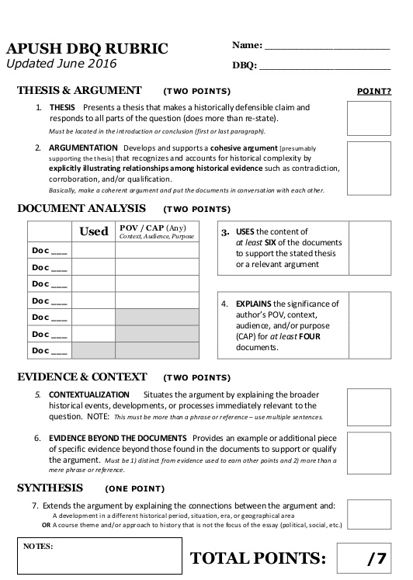

The most important part of this rubric to pay attention to when writing are contextualization, and synthesis. Remember also that referencing the documents is not enough, you must actually use them and give them meaning in relation to the question.

Whether you’re writing for an FRQ or DBQ, make sure everything always relates back to your thesis. You run the risk of writing an informative essay instead of an argumentative one if you don’t.

Activity 4: Grade the example FRQ or DBQ.

Activity 5: It’s essay time! The informational and argumentative prompts require at minimum five paragraphs, the summary requires three. You must complete all three prompts before you leave today!

APUSH Prompts, Chapters 3 & 4
Informational: How did Britain tighten its grip on North America?
Argumentative: Where did social hierarchy take hold in the colonies?
Summary: What are the key concepts from Chapters 3 and 4?

AP GOV Prompts, Chapter 2
Informational: How are British ideas seen in American government?
Argumentative: Why did the Articles of Confederation fail?
Summary: What are the key concepts from Chapter 2?

Activity 6: Chapter notes and vocabulary

AP Government Chapter 2 Vocab

- Constitution (general term)
- Declaration of Independence
- Natural rights
- Consent of the governed
- Limited government
- Representative government
- Right to revolution
- Conservative revolution
- Articles of Confederation
- Revolutionary War
- Shay’s Rebellion
- US Constitution
- Delegates (noun)
- State of nature
- Political conflict
- Distribution of wealth
- Factions
- Tyranny
- Checks and balances
- New Jersey Plan
- Virginia Plan
- Connecticut Compromise
- Writ of habeas corpus
- Separation of powers
- Republic
- Federalists
- Anti-federalists
- Popular sovereignty
- Bill of Rights
- Ratification
- Amend
- Judicial review

APUSH Chapter 3 Vocab

- Calvinism
- Predestination
- Conversion
- Puritans
- Separatists
- Mayflower Compact
- Plymouth
- Massachusetts Bay Colony
- Great Migration
- Freemen
- Protestant ethic
- Blue laws
- Antinomianism
- Fundamental Orders
- King Philip’s War
- Dominion of New England
- Navigation Laws/Acts
- Glorious Revolution
- Salutary neglect
- Patroonships

APUSH Chapter 4 Vocab
- Indentured servants
- Headright system
- Bacon’s Rebellion
- Middle Passage
- Congregational Church
- Jeremiad
- Halfway Covenant
- Salem Witch Trials
- Social hierarchy
- Leisler’s Rebellion

