This Election Is 1968 All Over Again, And That's Not A Good Thing

Trump is George Wallace on steroids. Cleveland resembles the Chicago of long ago. And the bottom line back then was Richard Nixon.

Howard Fineman Global Editorial Director, The Huffington Post
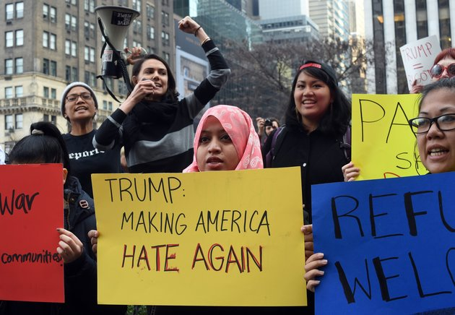

WASHINGTON -- It was the spring of a presidential election year, but there was no sense of hope and renewal in the land.

Instead, the United States was in the grip of tribalism and seething fear. Voters were energized by anger and resentment. The media ran red with violent language; surging crowds, cops and protesters filled city streets.

The main candidates were: a shopworn Democratic front-runner who embodied the party establishment; a white-haired, professorial anti-war protest candidate beloved by college students; a disruptive, race-baiting outsider with a knack for drawing press attention; and an unctuous, beady-eyed Republican lawyer practicing dirty tricks.
At its nominating convention in a Midwestern city that summer, one of the two political parties was torn apart, both inside the hall and out, as protestors clashed with police, who, it was later determined, were the instigators of the riots.

The general election hinged on which party could woo the most votes of a white working class that had been energized in the first place by the outsider candidate, who had railed against a powerful “Them” against “Us.”

That was 1968, not 2016.

Mark Twain allegedly said that “history does not repeat itself but it does rhyme.” If that is so, then this year has been that ancient -- but still very relevant one -- in a similar form.
That's not necessarily a good thing. Progress is always painful, and there was much pain in the decade that followed the disastrous, divisive and violence-filled 1968. And we can only hope that this year does not experience a season of assassination, the likes of which we had not seen since the Civil War and which we must never see again.

But that earlier election launched an era of discord and lawlessness, in high places and low. It created wounds that this election seems destined to deepen. The “political system” couldn’t handle the turmoil of 1968, and it is even less clear it can do so in 2016.
“The political institutions and traditions that held it all together back then aren’t nearly as strong,” said American Enterprise Institute scholar Norman Ornstein. “There is no trust, and the forces that are supposed to channel and cool the anger, such as Congress, are all working in the opposite direction.”

Why Wallace Matters
It may seem odd to link a Manhattan billionaire to a dirt-farm Alabama governor, but their messages are roughly the same -- just delivered more than four decades apart.
Like the late George Wallace, Trump exudes a sneering hatred for political establishments and blames the ills of the county on those whose race, faith or origin makes them somehow “un-American.”

Wallace softened somewhat in later years, but Trump, at 69, shows no signs of doing so. Indeed, he is doubling down on his willingness to allow verbal and even physical antagonism in his name and at his campaign rallies.

Indeed, it's his rallies -- more than Trump's tweets or called-in TV interviews -- that have become the central feature of his campaign, a theater of deliberate confrontation that he thinks adds energy and meaning to his angry candidacy.

Trump has far more clout and money in a system that's more fragmented and easier to penetrate. Far from being a fringe character -- which is what, in the end, Wallace was -- Trump is the party front-runner.

Social Conflict Spawns Party Discord
In 1968, the Vietnam War spawned a protest candidate, Sen. Eugene McCarthy of Minnesota, who played a role remarkably similar to that of Sen. Bernie Sanders this year.

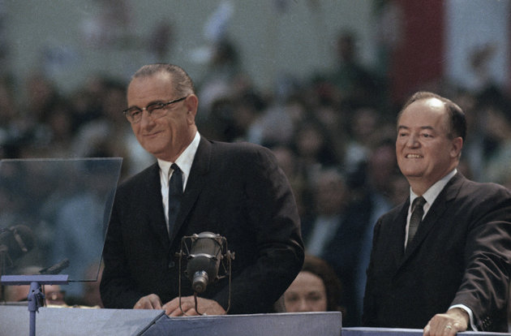
A critic of the war with a gift of seeming oblivious to politics as usual, the avuncular McCarthy inspired a generation of (Baby Boomer) students to volunteer at the grassroots, where they focused on New Hampshire (as did Sanders) as the key place in which to make their case.

But while McCarthy ran out of time, energy and money, Sanders has a broader platform and web-based crowdfunding to keep him going. And he is much more stubborn, ornery and driven than McCarthy ever was.

The Hillary Clinton role in 1968 was played by Hubert Humphrey, the beleaguered vice president of the by-then-wildly unpopular President Lyndon B. Johnson. Like Clinton, Humphrey had the support of most of the party’s establishment: African-Americans, unions, Jewish voters, elected officials at the federal, state and local levels.

But Humphrey was weighed down by the administration’s unpopular policies, chief among them the war and the draft. This time around, Hillary is having trouble defending her own version of interventionism (in the Middle East) as well as the free-trade and pro-big-business policies of both President Barack Obama and her own husband.
And the prospects for a disastrously disrupted convention this time aren’t on the Democratic side, but within the Republican Party.

For one, there is no certainty Trump will amass the 1,237 delegates that he needs for a majority before the GOP convention in Cleveland in July. Indeed, there is no certainty that, even if he does, it will prevent establishment efforts to derail him.

It will be messy, in part because the GOP hasn’t had such an experience since 1976 (when Ronald Reagan narrowly lost a challenge to President Gerald Ford) and the Trump people have no idea what to expect or how to plan.

“I’m not sure the Trump people fully understand what the establishment is going to try to do to them in Cleveland,” said Roger Stone, a longtime advisor, friend of Trump's and student of how to win (or disrupt) conventions.

The scene outside the arena in Cleveland could be even more chaotic. Hosts of protest groups, from Black Lives Matter to MoveOn.org to various Hispanics and Muslim groups, joined together to protest a Trump appearance in Chicago last week. They will have months to plan for Cleveland, and they have every reason to be indignant and afraid. (And they will show up for the Democrats in Philadelphia, too, no matter what Hillary and Bernie do to make peace.)
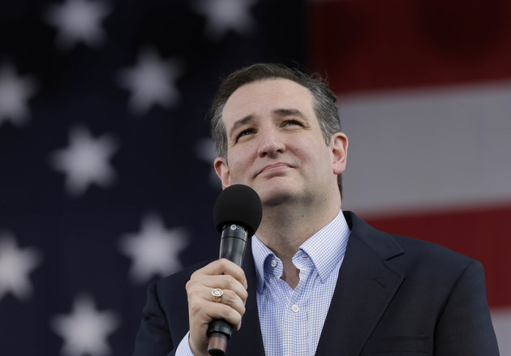

Sen. Ted Cruz (R-Texas), who is trying to play the role of unifier and peacemaker in the GOP, is almost chillingly reminiscent of the man who did that in 1968, Richard Nixon: beloved by no one, especially by colleagues in the U.S. Senate; a master of crude accusation clothed in legalistic rhetoric; as ruthless as he is sanctimonious.

Cruz seems unlikely to fold before Cleveland, and maybe not even then. If Trump gets the nomination, would Cruz lead a disillusioned “establishment” GOP out of the party?
Conversely, if Trump falls short and is denied the nomination, will he bolt the party and set up his own independent effort? That is what Wallace did to the Democrats in 1968.
If history does indeed rhyme, then Cruz still has a chance. And his strategy from the beginning has been to win the Trump voters over by the end of the campaign.

In the end, Nixon in 1968 won in part by co-opting the Wallace vote. In the name of a “silent majority” (a phrase Trump uses now) Nixon vowed to “bring us together” as one people, just as Hillary Clinton is now promising to do if she wins.

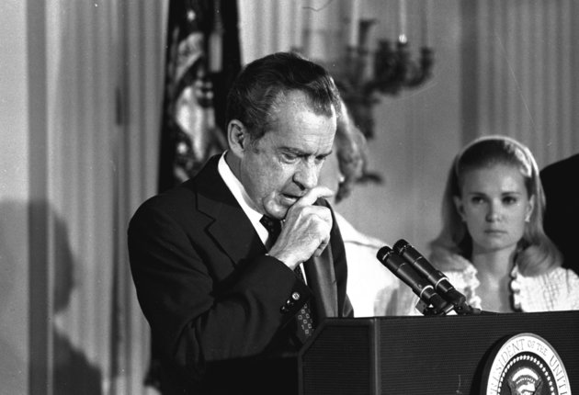
Far from bringing America together, Nixon eventually left town in the face of pending impeachment in 1974.

None of the current candidates would want history to rhyme that precisely. But it’s only 2016, and they will take their chances.

1. How does Mark Twain’s quote (“history does not repeat itself but it does rhyme”) apply to this situation? What do you think will happening if history is in fact “rhyming”?

2. What does Norman Ornstein mean when he claims “the forces that are supposed to channel and cool the anger, such as Congress, are all working in the opposite direction”?

3. Match the potential candidates from 2016 to the 1968 candidates they most mirror according to the article. Explain why the author matches them.

4. Considering the 1968 primaries, why does the author make reference to the upcoming Republican National Convention in Cleveland? What inferences can you make about what the author thinks will happen?

5. In the end, who won the election of 1968? From this and the author’s matches, who will most likely win the 2016 election?

Howard Fineman. “This Election is 1968 All Over Again, and That’s Not a Good Thing.” The Huffington Post. Published March 14, 2016. Accessed March 15, 2016. http://www.huffingtonpost.com/entry/1968-2016-election-parallels_us_56e5fb49e4b0b25c91824dce
This question does not necessarily reflect the author’s, your, or your teacher’s personal opinions. It is simply referencing the matches the author made between the 1968 and 2016 candidates in the article.

